Nama : Isep Lutpi Nur

NPM : 2113191079

Kelas : A2

Tugas : Latihan Pertemuan 6

1. Seleksi hari kerja dan libur

## Source Code:

**package** iseplutpi;

**import** **java.io.BufferedReader**;

**import** **java.io.InputStreamReader**;

**import** **java.io.IOException**;

*/\*\**

*\* LATIHAN PERTEMUAN 6 SELEKSI HARI KERJA*

*\* NAMA: ISEP LUTPI NUR*

*\* NPM: 2113191079*

*\* KELAS: A2*

*\*/*

**public** **class** **SeleksiHariKerja** {

**public** **static** void main(String[] args){

BufferedReader InputData = **new** BufferedReader(**new** InputStreamReader(System.in));

System.out.println("Program seleksi hari kerja dan hari libur");

String hari = "";

System.out.print("Silahkan masukan nama hari: ");

**try** {

hari = InputData.readLine();

}**catch** (IOException e){

System.out.println(e.getMessage());

}

hari = hari.toUpperCase();

**switch**(hari){

**case** "SENIN":

System.out.println("Hari kerja");

**break**;

**case** "SELASA":

System.out.println("Hari kerja");

**break**;

**case** "RABU":

System.out.println("Hari kerja");

**break**;

**case** "KAMIS":

System.out.println("Hari kerja");

**break**;

**case** "JUMAT":

System.out.println("Hari kerja");

**break**;

**case** "SABTU":

System.out.println("Hari libur");

**break**;

**case** "MINGGU":

System.out.println("Hari libur");

**break**;

**default**:

System.out.println("Hari yang anda masukan tidak terdaftar");

}

}

}

## Output:

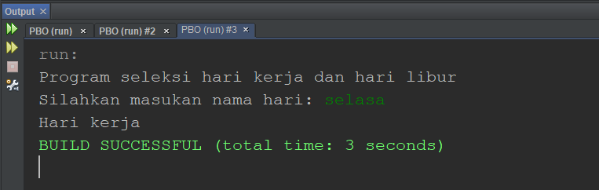

1. Hitung denda peminjaman buku

## Source Code:

**package** iseplutpi;

**import** **java.io.BufferedReader**;

**import** **java.io.InputStreamReader**;

**import** **java.io.IOException**;

*/\*\**

*\* LATIHAN PERTEMUAN 6 PEMINJAMAN BUKU*

*\* NAMA: ISEP LUTPI NUR*

*\* NPM: 2113191079*

*\* KELAS: A2*

*\*/*

**public** **class** **PeminjamanBuku** {

**public** **static** void main(String[] args){

BufferedReader InputData = **new** BufferedReader(**new** InputStreamReader(System.in));

String input = "";

int tglKembali = 0, blnKembali = 0, thnKembali = 0, tglPinjam = 0, blnPinjam = 0, thnPinjam = 0;

int selisih, selisihTgl, selisihBln, selisihThn, denda;

String kodeBuku = "";

System.out.print("Masukan kode buku: ");

**try** {

kodeBuku = InputData.readLine();

}**catch** (IOException e){

System.out.println(e.getMessage());

}

System.out.println("Masukan waktu pinjam:");

**try** {

System.out.print("Tanggal:");

input = InputData.readLine();

tglPinjam = Integer.parseInt(input);

}**catch** (IOException e){

System.out.println(e.getMessage());

}

**try** {

System.out.print("Bulan:");

input = InputData.readLine();

blnPinjam = Integer.parseInt(input);

}**catch** (IOException e){

System.out.println(e.getMessage());

}

**try** {

System.out.print("Tahun:");

input = InputData.readLine();

thnPinjam = Integer.parseInt(input);

}**catch** (IOException e){

System.out.println(e.getMessage());

}

System.out.println("Masukan waktu Kembali:");

**try** {

System.out.print("Tanggal:");

input = InputData.readLine();

tglKembali = Integer.parseInt(input);

}**catch** (IOException e){

System.out.println(e.getMessage());

}

**try** {

System.out.print("Bulan:");

input = InputData.readLine();

blnKembali = Integer.parseInt(input);

}**catch** (IOException e){

System.out.println(e.getMessage());

}

**try** {

System.out.print("Tahun:");

input = InputData.readLine();

thnKembali = Integer.parseInt(input);

}**catch** (IOException e){

System.out.println(e.getMessage());

}

selisihThn = (thnKembali - thnPinjam) * 365;

selisihBln = (blnKembali - blnPinjam) * 30;

selisihTgl = (tglKembali - tglPinjam);

selisih = (selisihThn + selisihBln + selisihTgl);

denda = (selisih >= 3) ? (selisih - 3) * 1000 : 0;

System.out.printf("Kode buku: %s\n", kodeBuku);

System.out.printf("Tanggal pinjam: %d/%d/%d \n", tglPinjam, blnPinjam, thnPinjam);

System.out.printf("Tanggal Kembali: %d/%d/%d \n", tglKembali, blnKembali, thnKembali);

System.out.printf("Denda: Rp. %d,- \n", denda );

}

}

## Output:

